Instance block control flow

1. **What is control flow, if everything is instance related?**
   1. Identification of instance members from top to bottom.
   2. Execution of instance variable assignments and instance blocks from top to bottom.
   3. Execution of constructor.
2. **Example**:  
   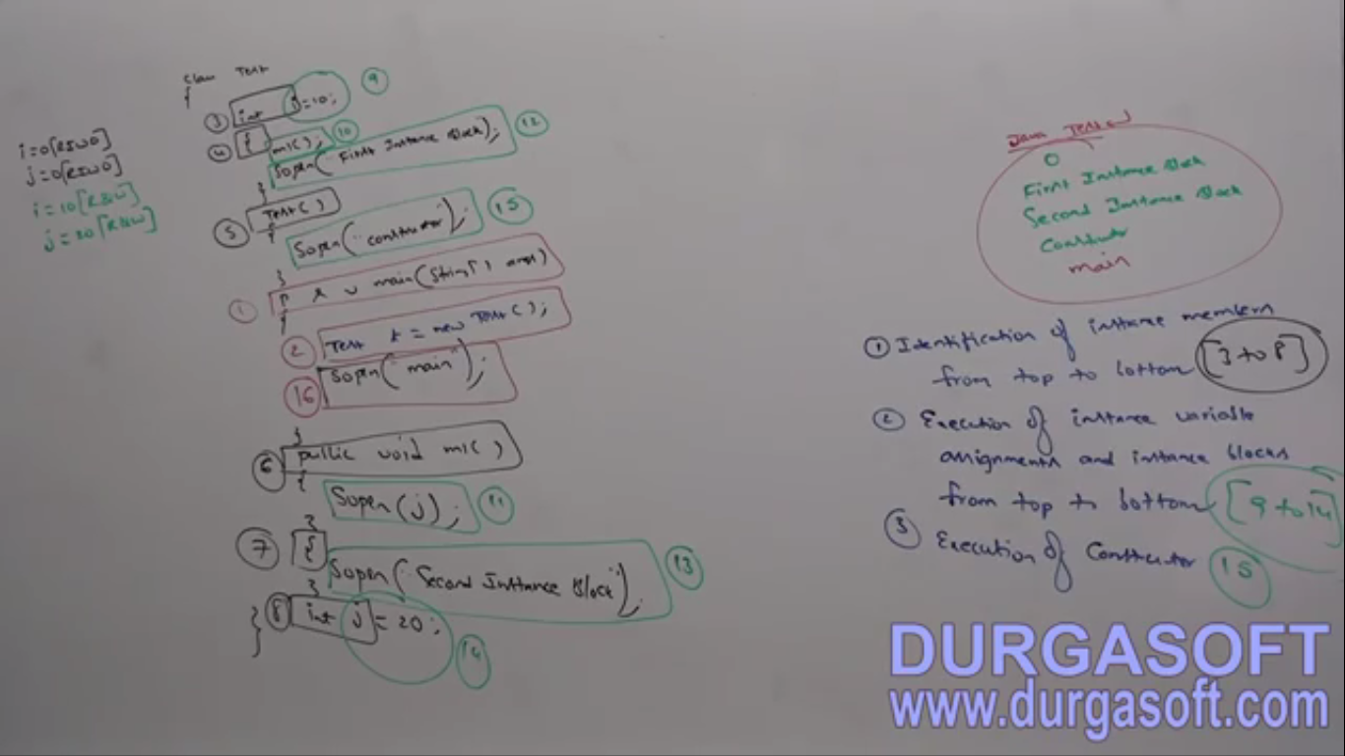
3. Static control flow is one time activity which will be performed at the time of class loading.

Instance control flow in Parent-to-Child Relationship

1. **Control flow**
   1. Identification of instance members from parent to child.
   2. Execution of instance variable assignments and instance blocks **only** in **parent class**.
   3. Execution of **parent constructor**.
   4. Execution of instance variable assignments and instance blocks **only** in **child class** now.
   5. Execution of **child constructor**.
2. **Example**:
3. 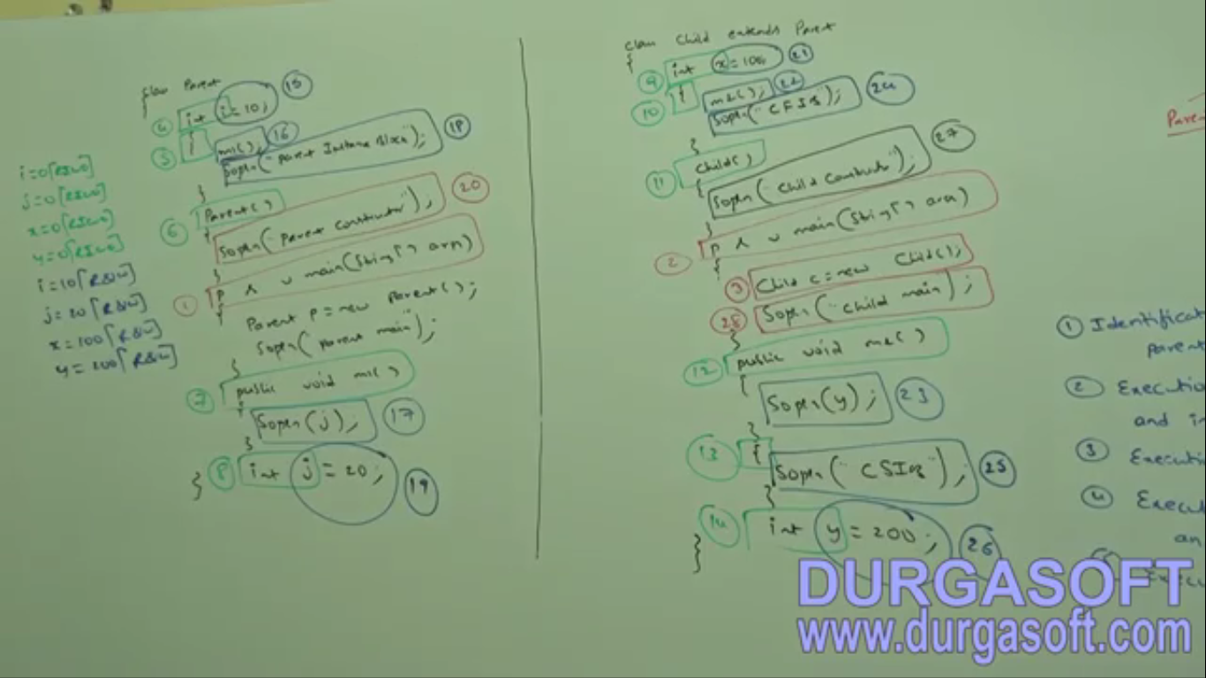

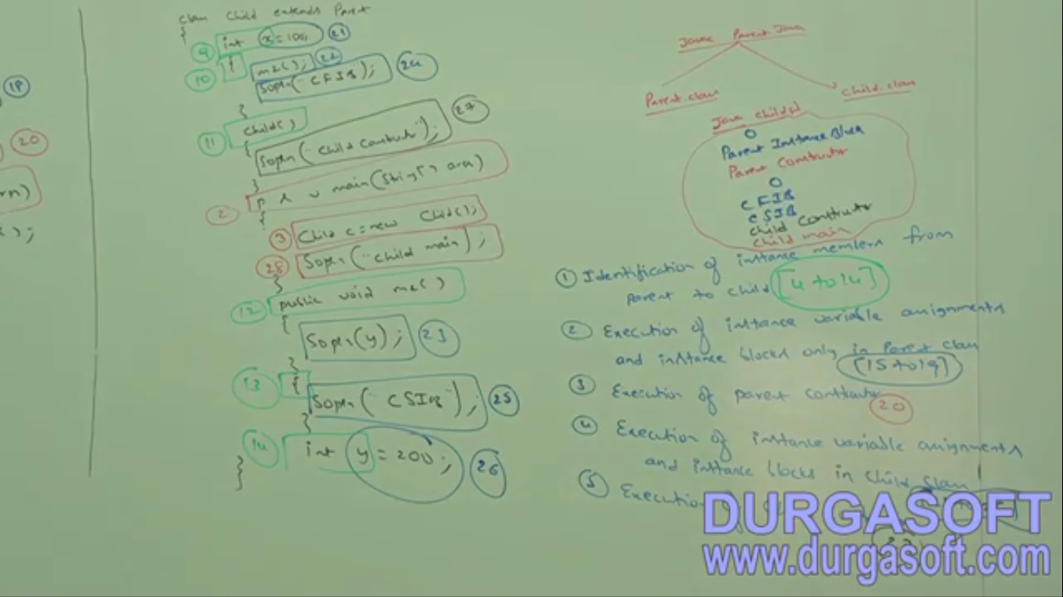

1. d